1. How to get help while working in MongoDB Shell.
2. Commands:
   1. help
3. help:  
   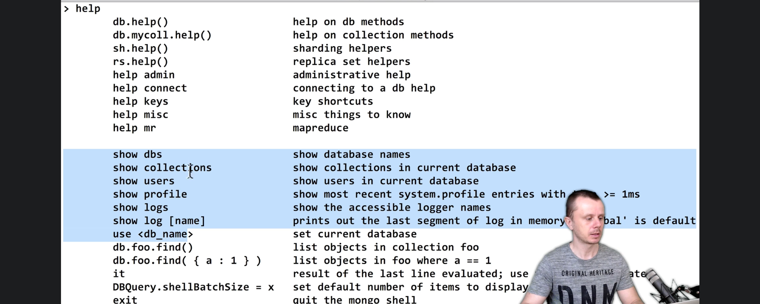
4. Not Complete